**Lab 12: Configuring HDFS Storage Policies**

Assign the DISK storage type to DataNodes disks and assign a storage policy to an HDFS directory.

Use HDFS command-line commands to create a warmdata directory in the root user’s HDFS home directory. Verify that the directory was created.

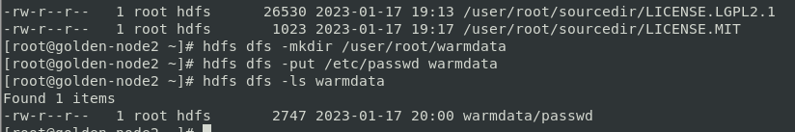

**Assign the DISK storage type label to the DataNode disks using the Ambari Web UI.**

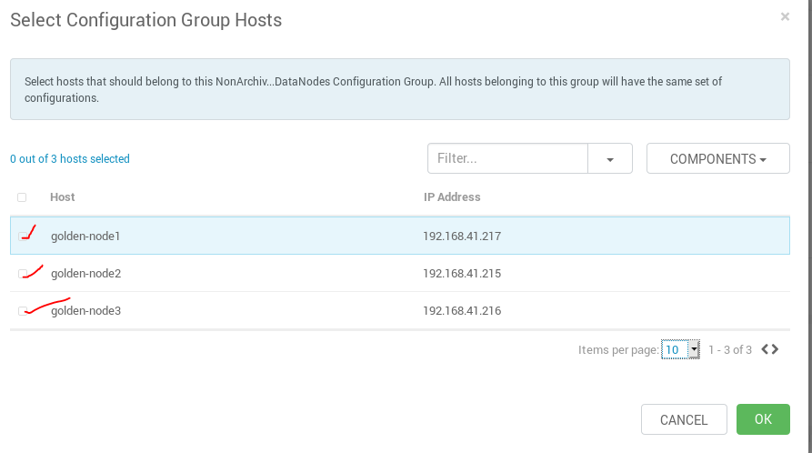

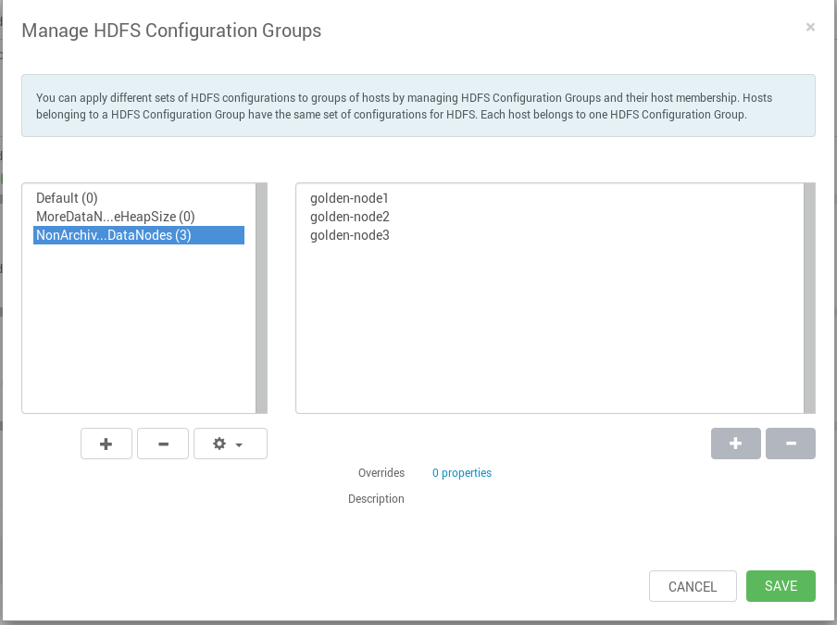

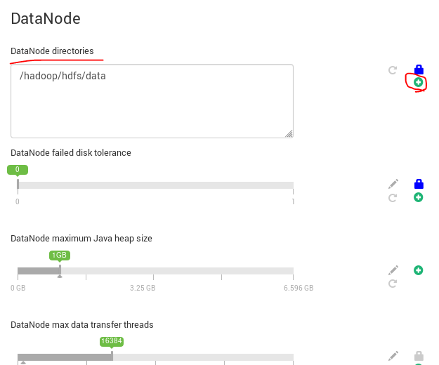

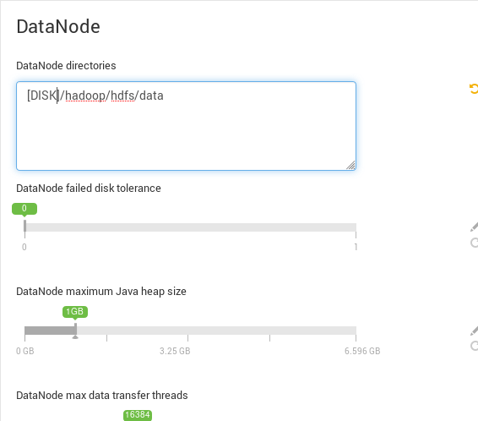

List the storage policies available in HDFS

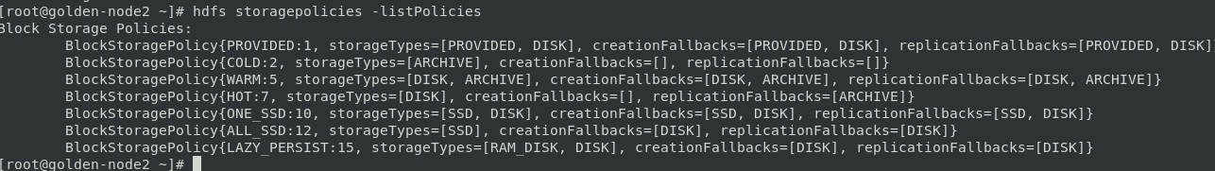

Assign the WARM storage policy to the data in the /user/root/warmdata directory.



**Examine the disk locations and storage types for data blocks controlled by a storage policy.**

a. Run the HDFS fsck utility to display the block locations and their storage types for the /user/root/warmdata/passwd file.

